7_0 Introduction

Dijkstra Algorithm
-Single Source Shortest Distance

7_1 Why we need to learn Dijkstra

Weight
- Dist
- Time
- Tk / Cost

Unweighted - > BFS
Weighted - > Dijkstra

7_2 Path relaxation

7_4 Dijkstra Naive Approach
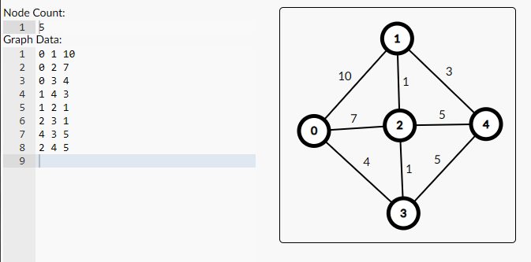

7_5 Adjacency list for weighted graph


5 8
0 1 10
0 2 7
0 3 4
1 4 3
1 2 1
2 3 1
4 3 5
2 4 5

```
#include<bits/stdc++.h>
using namespace std;

int main(){
int n, e;cin>>n>>e;
vector<pair<int, int>> adj_list [n];
while (e--)
{
int a, b, c;cin>>a>>b>>c;
adj_list[a].push_back({b,c});
adj_list[b].push_back({a,c});
}
for (int i = 0; i < n; i++)
{
cout<<i<<" -> ";
for(pair<int, int>p : adj_list[i]){
cout<<p.first<<" "<<p.second<<", ";
}cout<<endl;
}

return 0;
}

```

7_6 Dijkstra Naive Implementation

During using of memset to assign value “INT_MAX” to all the node, memset fails
So, what will we do. We will just manually keep/assign value through for loop

Code : ```
#include<bits/stdc++.h>
using namespace std;

vector<pair<int, int>> adj_list [105];
int dis[105];

void dijkstra(int src){
queue<pair<int, int>>q;
q.push({src, 0});
dis[src] = 0;
while (!q.empty())
{
pair<int, int> par = q.front();
q.pop();
int par_node = par.first;
int par_dis = par.second;

// for(pair<int, int> child: adj_list[par_node]){
for(auto child: adj_list[par_node]){
int child_node = child.first;
int child_dis = child.second;
if(par_dis + child_dis < dis[child_node]){
dis[child_node] = par_dis + child_dis;
q.push({child_node, dis[child_node]}) ;
}
}
}

}

int main(){
int n, e;cin>>n>>e;

while (e--)
{
int a, b, c;cin>>a>>b>>c;
adj_list[a].push_back({b,c});
adj_list[b].push_back({a,c});
}

for (int i = 0; i < n; i++)
{
dis[i]=INT_MAX;
}

dijkstra(0);

for (int i = 0; i < n; i++)
{
cout<<i<<" -> "<<dis[i]<<endl;
}

return 0;
}

// input:
// 5 8
// 0 1 10
// 1 2 1
// 0 2 7
// 0 3 4
// 2 3 1
// 3 4 5
// 1 4 3
// 2 4 5

// output:
// 0 -> 0
// 1 -> 6
// 2 -> 5
// 3 -> 4
// 4 -> 9

```

7_8 Complexity of Dijkstra Naïve
O(VE)

